
Softech Environmental Policy

Softech S.r.l. has activated its ISO 14001 management system since July 2011 and has defined as its field of application the design and development of IT systems relating to systems for surveying and processing data in the areas of traffic control, safety, environment and industrial automation, including assembly and installation of control units. Operational Headquarters: Via Ferni, 2 Gallarate.
The company aims to constantly work to ensure that the activities related to its production are increasingly compatible with the environment and the health of employees and the community in general
With this in mind, the Management has therefore established the following Environmental Policy:
- Ensure respect for the environment in which it is located, preventing all forms of pollution, to protect all interested parties.
- Ensure respect for the environment while carrying out any planned off-site activities, to protect all interested parties and in light of their expectations.
- Ensure compliance with the legal requirements and other signed requirements (applicable to the identified environmental aspects) by periodically assessing compliance and promptly responding to any changes thereto.
- Verify any environmental implications in each order and operate appropriately to reduce any environmental impacts.
- Pursue the continuous improvement of its environmental performance.
- The Management, in line with the declared Environmental Policy, has defined the following reference points and objectives:
- Maintain the environmental certification according to the UNI EN ISO 14001: 2015 standard
- Set up improvement actions aimed at reducing the most significant impacts.
- Implement the procedures necessary for the management of each new environmental directive.
- Ensure the dissemination and understanding of its Environmental Policy within the Company.
- The Management confirms its commitment to ensure that this Environmental Policy is made available for any external request.
All personnel, suppliers and other interested parties are required to be fully available to actively collaborate, as far as they are concerned, in improving the Environmental Management System.

Management

Marco Renda – Mauro Roncari

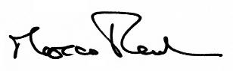 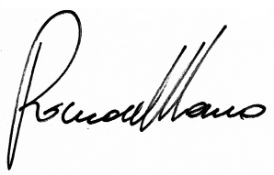 November 2019

